Welcome to the Den

Business Education (ADST - Entrepreneurship) 8

OVERVIEW & PURPOSE
Entrepreneurial and Innovative mindsets are extremely important in this current and future job market. For this project, you will engage in the Design Thinking process in order to solve a problem in your personal life, in your school life, or in your community. At the end of this unit you will present your projects to the Dragons who will have an influence over your final mark.
The world is full of problems. My question to you is, which one do you want to solve?
On your own, or in a group of a maximum of 3, decide on a problem either in your own life, in your school community, or in your larger community that you want to solve.

THE PROPOSAL
By FRIDAY, January 31, you will need to submit a Project Proposal.
- Project Title (Company Name/Product Idea)
- Overview - the problem you are trying to solve, the audience, the purpose, the inspiration (what’s the story behind the problem? Empathy and Defining the Problem)
- Goals - what do you hope to accomplish? (How will what you come up with benefit your audience? Brainstorming and Ideation)
- Research Methods - what research do you need to do in order to better understand the problem and the people you are trying to help? (Active Research vs. Basic Research)
Before investing time and money, make sure your problem is approved by your teacher.

THE PROCESS
Once your problem has been approved, you will complete daily meeting minutes with brainstorming, research, and accomplishments.
Record ALL ideas, possible solutions, everything must be recorded in the Word document under the DATE of discussion. These will be submitted to your teacher.

THE PITCH
You will be presenting your project, pitching your idea, to 3-5 Dragons LIVE on
FEBRUARY 25th - No exceptions, or extensions.
In your final presentation of MAX 5 minutes, you will present your problem, rationale, solution, and successful prototypes. How you choose to present yourselves to the Dragon's is up to you - we will discuss strategies in class prior to presentations.

THE DESIGN THINKING PROCESS
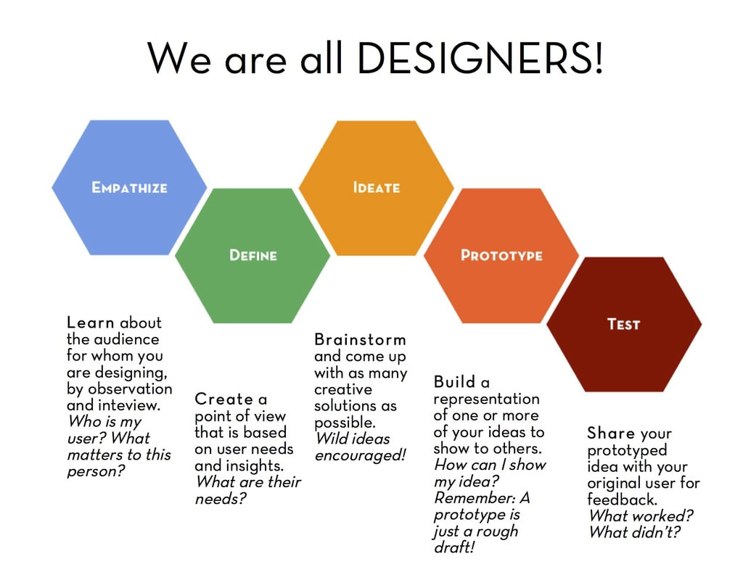
Source: http://steamcurriculum.weebly.com/design-thinking.html
Design Thinking is a cyclical and linear process that is extremely useful for problem solving, innovation and entrepreneurial thinking.
- It begins with Empathy. When we develop a deeper understanding of the challenges we face either as individuals, as a school community, or as a local or global community, we can better identify possible solutions.
- Then comes Defining the Problem. Once we've identified the challenges we face, we can clearly articulate the problem we want to solve.
- Brainstorming or Ideate is the next step. Here we brainstorm all the possible solutions - both big and small, out of this world, and realistic. This helps us refine, select, and develop solutions to our problem and challenge.
- Then we create our Prototypes, or series of prototypes to test all or parts of our solutions.
- Finally, we Test​ our prototypes by sharing them with others and making.

MILESTONES AND DEADLINES – Important dates for the project
Monday, Jan 27 - Project Given and Discussed; Brainstorming – Understanding the problem
Wednesday, Jan 29 - Groups made; Define the problem; Brainstorming and Make Proposal
Friday, Jan 31 - Proposal Due; feedback loop with classmates
Tuesday, Feb 4 – Prototype, Iterate, Adjust Proposal
Thursday, Feb 6 - Prototype, Research, Iterate, Adjust Proposal
Monday, Feb 10 – First Meeting with your teacher; first prototype should be done.
Wednesday, Feb 12 - How to give a good presentation, Design Thinking, Script
Friday, Feb 14 – Financial Planning
Wednesday, Feb 19 - Second Meeting with teacher; finalizing presentations
Friday, Feb 21 - Dress Rehearsal & Tech Check
Tuesday, Feb 25 - Enter the Den

PROJECT ASSESSMENT

- Applied Design – Empathizing, Understanding Context & Defining
DEVELOPING | PROFICIENT | EXTENDING
We are still working to clearly define the problem our product is solving. We are working on explaining how our product helps our target market. | We can clearly define and communicate the problem we are solving and explain how our product satisfies the needs of our target market specifically. We understand the needs of our target market. | We can clearly define and communicate the problem we are solving and explain how our product satisfies the needs of our target market specifically. We can effectively describe how our product is better than any of our competitors’ products. We have a very good understanding of our target market.
- Applied Design – Prototyping, Testing and Making
DEVELOPING | PROFICIENT | EXTENDING
I/We used decision making strategies to make our prototype. We created a (1) prototype; did not test or adjust.  We tried to participate in the feedback loops but were unprepared. | I/We used decision making strategies to further our prototype(s). We created multiple (2) prototypes that evolved with testing.  We used some of the feedback from our peers/teachers to improve our product. | I/We used decision making strategies to further our prototype(s). We created multiple (3+) prototypes that evolved with testing.  We considered all feedback from our peers/teachers to improve our product.
- Applied Technologies
DEVELOPING | PROFICIENT | EXTENDING
We are working on creating effective presentations that apply appropriate tools & technologies that follow most of the criteria below:  - little to no text,  - high contrast background and text,  - high quality pictures  - effective animations to engage the audience. | We can create effective presentations by applying the appropriate tools & technologies that follow most of the criteria below:  - little to no text,  - high contrast background and text,  - high quality pictures  - effective animations to engage the audience. | We can create effective presentations by applying the appropriate tools & technologies that follow all the criteria below:  - little to no text,  - high contrast background and text,  - high quality pictures  - effective animations to engage the audience.
Comments:

