FOMP 10 Name: ______________________

**Right Triangle Trigonometry Chapter Review** Block: ______ 

**2A Identifying which ratio to use and how to set up your equation:**

**1.** Identify the hypotenuse, opposite side, and adjacent side associated with each indicated angle.

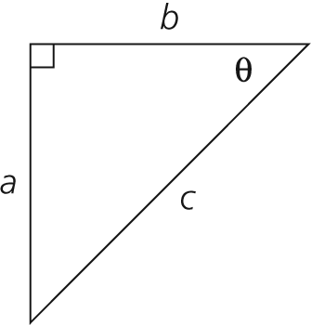Hypotenuse:



Opposite:



Adjacent:



**2.** In the triangle below, what would determine the sin ratio of angle B.





sin B = **_________**

C

A

B

80mm

**3.** A right triangle has $sinθ=\frac{3}{5}$. What is the value of $tanθ$? **Hint: You will need to use the Pythagorean Theorem** **(2 marks)**



tan  = __________

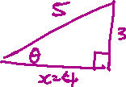

|  |
| --- |
| 1. Identify the statement that is NOT RIGHT for the triangle below.      * 1. b.   c.  d.  e. |



What is the length of side *y* in the following diagram, *to the nearest tenth of a centimetre*?

**2B Finding missing angles in triangles**

1. Determine the measure of ∠θ, *to the nearest tenth of a degree*.

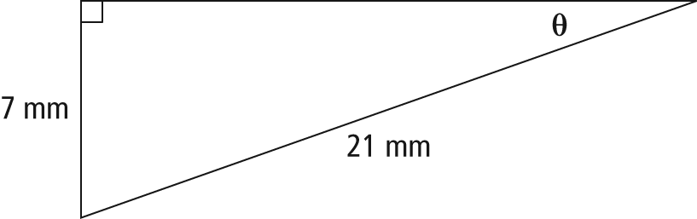



**<** θ =



1. Determine the measure of ∠β, *to the nearest degree*.

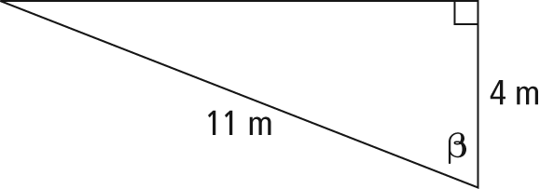



**<** β =



1. **B is halfway from A to F. What is the measure of** ? Remember that angles in a triangle add up to 180 degrees!

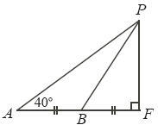



**9.**  Find ‘x’ to the tenths



|  |  |  |
| --- | --- | --- |
| a)   1. x = | b)   1. x = | c)  x   1. x = |

**10.** Daniel’s math class went on a field trip to Métis Crossing, AB. At the park gates, a Canadian flag is raised on a flagpole. Daniel stands directly under the flagpole and walks 10 ft away. He then turns around and uses the clinometer he brought with him to determine the angle of elevation to the top of the flagpole to be 58°. If Daniel’s eyes are 6 ft from the ground, what is the height of the top of the flagpole, *to the nearest foot*?

Complete the **diagram**.

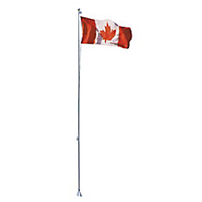 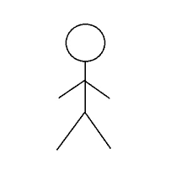



Daniel

**8.**



**



11.

Find the area of the triangle.

*11.*



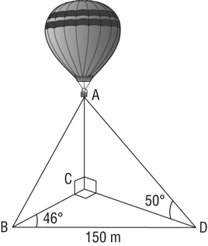12. The Saskatoon Balloon Festival is organized by Sundance Balloons and the Canada Remembers Airshow. In Kinsmen Park, Wayne has tethered his balloon to the ground at points B, C, and D, using three guy wires, as shown.

a) What is the length of CD, *to the nearest tenth of a metre*?



a**)**



1. What is the height of the hot air balloon, *to the nearest tenth of a m*etre?

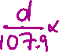

|  |  |  |  |  |
| --- | --- | --- | --- | --- |
| **Communicating and Representing** | **Emerging** | **Developing** | **Proficient** | **Extending** |
| * My solution communicates my thinking clearly. Others can understand my thinking. * My solution is neat and organized * My solution is logical and well-reasoned |  |  |  |  |

b**) [1]**



For more review questions, please turn to P. 124 – 126 in your textbook!