Starter: Joe works at Superstore and earns $15.00 per hour. Employees are paid for each hour worked, no part hours. Let h = number of hours, d = dollars earned.

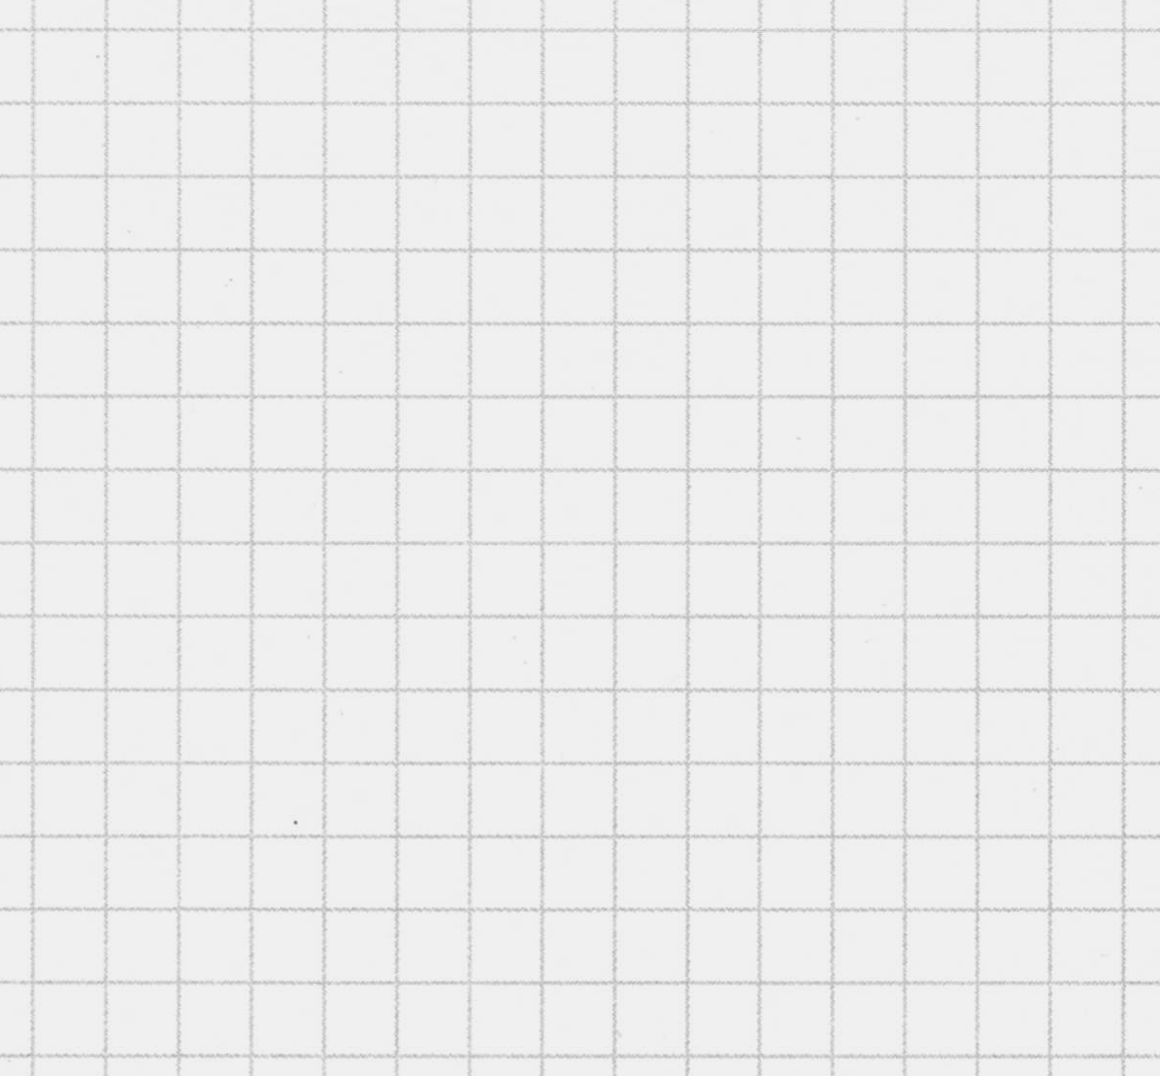
- Make a table of values up to 4 hours.

- Identify the independent variable and dependent variable.

- Write the domain and range.

- Graph out the function on the grid provided.

- Is this relation a function? Explain.

- Write a mathematical equation to describe this relation. Clearly identify your variables.

In the workplace, a person’s gross pay (before taxes), often depends on the number of hours worked. This is why sometimes the gross pay is called the _______________________________ while the number of hours worked is called the _______________________________________.

A picture of a function and its terminology:

____________ or ______________ or

__________________________ ________________________
“the item you put in” “the product you get out”

An equation is just a relationship between an INPUT and an OUTPUT. The above particular equation with two variables is a function and thus can be written in ___________________ notation. To change the equation into function notation, we can do the following…

If there is no context to the problem, then the variables used in the equation are _____ and ________.

Example 3: For the equation 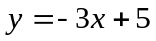, rewrite using function notation and evaluate 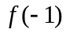. Then determine ‘x’ when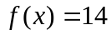.

Example 4: For the equation 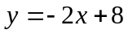, rewrite using function notation and then determine ‘x’ when.

Example 5: Forensic anthropologist study human remains to understand more about how people develop. For example, the measurement of a person’s radius (outer bone in arm – not circle!) can be used to approximate a person’s height. The equation for females is 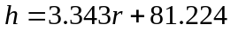, where ‘h’ is the height of the female in centimeters and ‘r’ is the length of the radius in centimeters.

- Write the equation using function notation. Describe the function.

- Determine the value of 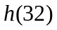and explain what this number represents.

- Determine the value of “r” when 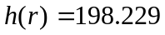 and explain what this number represents.

Example 6: Sunscreen has different protection factors, for example 2, 4, 8, 15, 25, 30, 45 SPF. The percent (p) of the sun’s UV light passing through a sunscreen is a function of its protection factor (s). The formula is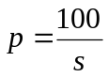.
- Re-write the equation using function notation.

- Find the percent of the UV light that passes through SPF 4, 8 and 30 each sunscreen factor.

- If Mr. Lee is wants to avoid getting skin cancer and only wants to ensure that 95% of the sun’s UV rays will not penetrate his skin, what in the minimum SPF factor sunscreen that he can buy?

Example 7: The area of a rectangle with length “L” centimeters and width “W” centimeters is 12 cm². Express the perimeter of the rectangle as a function of its length. Draw a picture to help you out.

Home Learning for Section 5.2: Page 270: 14, 15, 18, 19, 21 Challenge: 20, 22, 23

