***Investigation #1:***

Find the slopes of the two sets of lines below

**SET A:** **SET B:**



Slope Line 1 = Slope Line 2 = Slope Line 1 = Slope Line 2 =

What do you notice about slopes of parallel lines vs. non-parallel lines?

***Investigation #2:***The two sets of lines below are both perpendicular to each other…

 

**SET A SET B:**

Slope Line 1 = Slope Line 2 = Slope Line 1 = Slope Line 2 =

What do you notice about the slopes of perpendicular lines?

***A QUICK SUMMARY…***

**SLOPE: __________________________________________________________________________**

**PARALLEL LINE SEGMENTS:** If 2 lines are parallel, then their slopes are ________________.

**PERPENDICULAR LINE SEGMENTS:** If 2 lines are perpendicular, then their slopes are ________________________________, or the two slopes ______________________________.

**Example 1:** Is line MN parallel or perpendicular to line PQ if the coordinates of all points are:

M(5,-1) ; N(2,3) and P(2,-2) ; Q(-1,-6)

**Example 2:** The points P(2, –5), Q(–2, 1), and R(3, –1) are given. Find the coordinates of a point T on the *y*-axis so that segment RT is parallel to PQ.

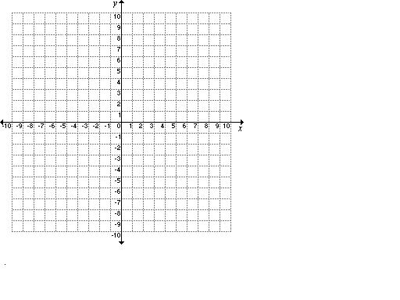

Home Learn

**Example 3:** Determine the slope of a line that is perpendicular to a line passing through S(6,3); T(-1,-6).

**Example 4:**  A triangle has vertices A(–2, 3), B(8, –2) and C(4, 6). Is it a right triangle?



**Example 6:** A line segment has endpoint C(6, 2) and D(8, 5).

a) Point P is such that PC is parallel to CD. Find the coordinates of P if P is on the:

 i) *y*-axis ii) *x*-axis

b) Point P is such that PC is perpendicular to CD. Find the coordinates of P if P is on the:

i) *y*-axis ii) *x*-axis

iii) CHALLENGE: the 45o line of 

**Home Learning: Page 349: 5, 8, 9, 12, 13, 17, 23 Challenge: 24**