**Review of Terminology:**

* DOMAIN of a function is the set of values for the ___________________ variable, or __________.
* RANGE of a function is the set of values for the ____________________ variable, or __________.

**Example 1: How to express a domain and range**

|  |  |
| --- | --- |
| **Domain** | **Range** |
| **Words** | **Words** |
| **Set Notation** | **Set Notation** |
| **Interval Notation** | **Interval Notation** |

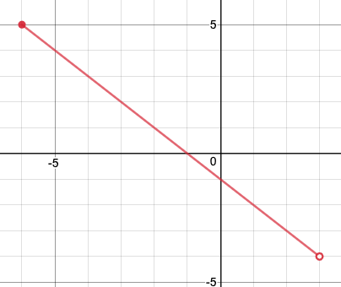

|  |  |
| --- | --- |
| **Domain** | **Range** |
| **Words** | **Words** |
| **Set Notation** | **Set Notation** |
| **Interval Notation** | **Interval Notation** |

1. 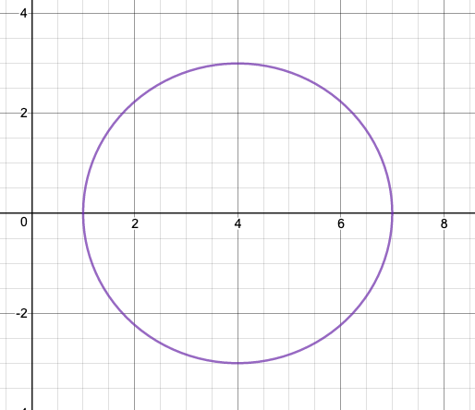

**Important Symbols for Set Notation**

**Interval Notation**

* [ ] style bracket if ______ number is included (closed dot)
* ( ) style of bracket if ____ number is ____ included. (______ dot)
* The ___________ symbol _____ is used if there is ____ end point.

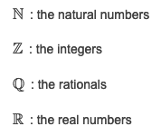

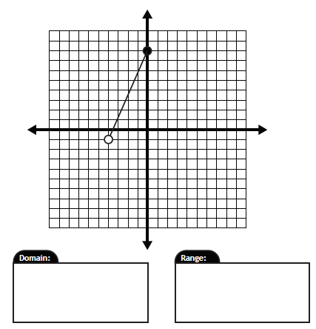 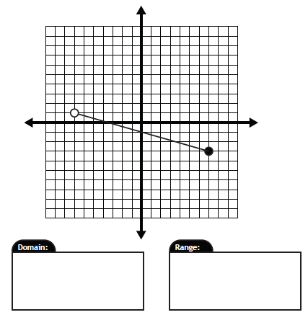

|  |  |
| --- | --- |
| **Domain** | **Range** |
|  |  |

|  |  |
| --- | --- |
| **Domain** | **Range** |
|  |  |

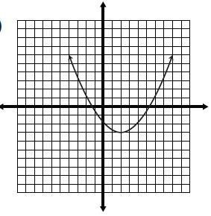 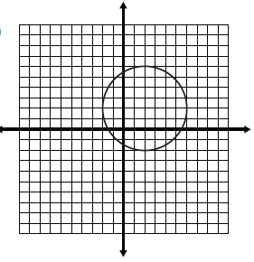

|  |  |
| --- | --- |
| **Domain** | **Range** |
|  |  |

|  |  |
| --- | --- |
| **Domain** | **Range** |
|  |  |

**Example 7:** Given the following graph below,

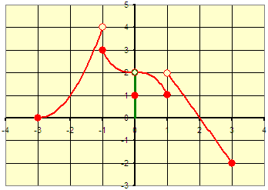

1. determine the domain value when the range value is 3
2. determine the range value when the domain value is 5
3. 
4. find ‘x” if .
5. 
6. find ‘x” if .

**Home Learning: Page 294: 6, 7, 9, 10, 11, 16, 17 Challenge: 21, 23, 24**