Math 9 Name:
SECTION 7.1 AND 2 Home Practice: Maps Worksheet Period:

- On a map with a scale of 1 : 50 000 000, what actual distance, in kilometres, is represented by 4 cm?

- On a map with a scale of 1 : 100 000 000 what distance, in centimetres, represents an actual distance of 2500 km?

- Charlottetown is 976 km from Ottawa. How far apart are they on a map with a scale of 1 : 20 000 000?

- St. John’s is 2125 km from Toronto. How far apart are they on a map with a scale of 1 : 50 000 000?

- If two cities are 5.8 cm apart on a map and the actual distance between them is 145 km, what is the scale of the map?

Use the following map of Alberta to answer the following questions.

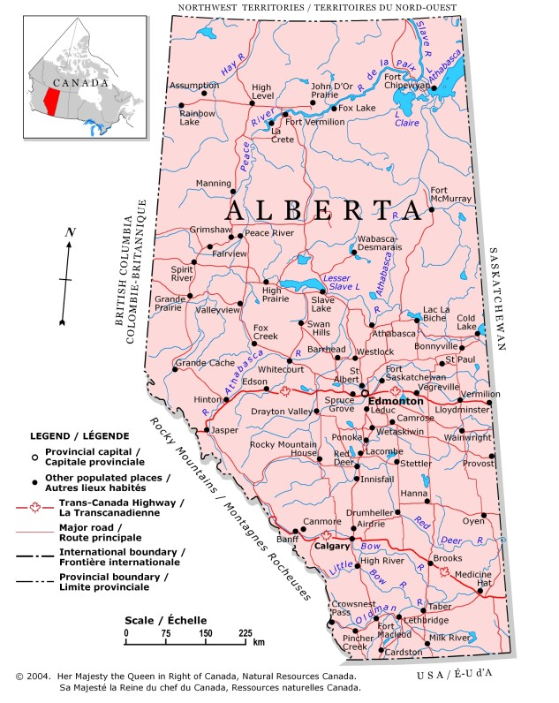

- Determine the scale factor of the map with the units shown:

- 1 cm : ______ km (ii) 1 cm : _____________________ cm

- Which of the above do you think will be easier to use? Explain.

- Use the scale to determine the approximate straight line distance between:

- Calgary and Edmonton

- St. Albert and Red Deer

- Innisfail and Drumheller

Use the following map of Ontario to answer the following questions.

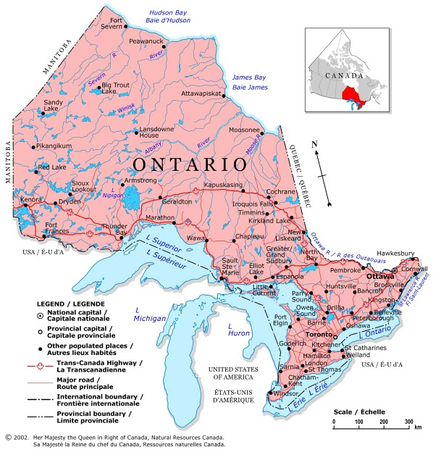

- Determine the scale factor of the map with the units shown:

- 1 cm : ______ km (ii) 1 cm : _____________________ cm

- Use the scale to determine the approximate straight line distance between:

- Thunder Bay and Cochrane

- Toronto to Ottawa

- Windsor to Fort Severn

- Calculate the approximate driving distance from Thunder Bay to Cochrane. How much longer is it than the straight line distance calculated above?

- What is the approximate width of Ontario? What length did you measure to determine the answer?

Road Maps

- The official road map of Ontario has a scale of 1:700 000. Explain what this ratio means.

- How many kilometres does 1 cm on the map represent?

- Calculate the actual distances represented on the official Ontario road map by:

(a) 3 cm (b) 0.8 cm

- Use this map to complete the table of driving distances.



