***Investigation #1:***

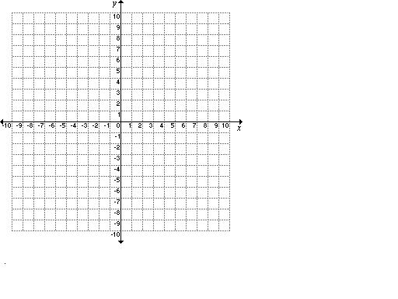Graph out the following functions (use a table of values if needed to help you out): 1.  2.  3.

In general, how does the ‘b’ in  change the appearance of the graph?

***Investigation #2:***

Graph out the following functions (use a table of values if needed to help you out): 1.  2.  3.

In general, how does the ‘m’ in  change the appearance of the graph?

In general, for the equation of a line in the form …

‘m’ = ______________________ “b” = ______________________________

This is also known as the ___________________________ of the equation of a linear function (line)

**Example 1:** State the slope and y-intercept of the following equations.

a)  b)  c) 

**Example 2:** Draw the lines on the grid to the right and then find the equations of the lines.

1. ****Start at point A(0,4) and draw a line with a slope of .
2. Draw a line through B(-4, 5) with a   
   slope of .

**Example 3:** Find the slope, y-intercept, then write out the equation of the line.

a) b)

**Example 4:** Graph the line. Don’t use a table of values. (find y-intercept, then slope.)

****a) 

b) 

c) 

**Example 5:** On the grid to your right…

1. ****draw a line through P(3, –1) with a slope of –3 and   
   then find the equation of the line.
2. draw a line through K(5, 4) that is parallel   
   to the line in part a.   
   Then find the equation of this new line.
3. Draw a line through K(5,4) that is perpendicular to the line in part a. Then find the equation of this perpendicular line.

**Example 6:** An equation of a line is y = mx + 5. Determine the value of “m” when the line passes through the point (-2, -13).

**Example 7:** To join KUMON+, an improved math system to KUMON, students need to pay a membership fee of $25, plus a monthly fee of $14.

1. write an equation for the total cost, “C” dollars, for “n” months at the math centre.
2. Suppose you attended the math centre for 2 years, what was the total cost?
3. Suppose the total cost was $515, how many months did you use the math centre for?

**Example 8:** The line represented by  and a line perpendicular to it intersect at R(1, 1). Find the equation of the other line.

**Home Learning for Section 6.4: Page 363: 5ace,7ac, 8, 11, 12, 14, 17, 21, 22**

**Challenge: Page 364: 23, 24**