Recall from previous classes the different ways to represent the equation of a line:

* slope-intercept form is ____________________, where “m” = _________, “b” = _________
* Slope-point for is _________________________, where “m” = _________ and you have a point!

In section 6.6, we will show you TWO MORE ways to express the equation of a linear function!

Linear Equations can also be written in two other forms…

STANDARD FORM: ________________________ Note: A, B, and C are ______________.

The ____________________ is on the right hand side.

GENERAL FORM: _________________________ Note: A, B & C are __________& _____.

The ____________________ is on the right hand side.

These forms can be found by first finding the equation of the line in either slope-intercept form or slope-point form, then doing algebraic manipulation to get it into the proper forms.

**Example 1:** Find the equation of a line with slope 4 that passes through the point A(2, 5). Do this by  *finding the slope-intercept form first, then ending with the general form.*

1. Write the equation in slope-intercept form.
2. Write the equation in standard form and then in general form.
3. Find the x-intercept of this line.

**Redo Example 1:** Find the equation of a line with slope 4 that passes through the point A(2, 5). This time, *find the slope-point form first, then ending with the general form.*

1. Write the equation in slope-point form.
2. Write the equation in standard form and then in general form.

**Example 2:** Find the equation of a line with slope  that passes through the point (-3, 9). Write your final answer in general form. Use whatever method you wish.

**Example 3:** Find the equation of a line that passes through the points R(1, 5) and T(2, –1). Write your answer in slope-point form and then in general form.

**Example 4:** Graph out the following equations written in standard or general form by first finding both the x and y intercepts.

Plot part “a” and “b”

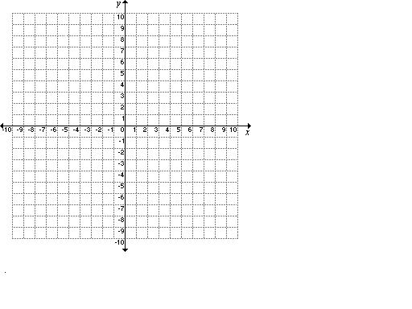. a) 4x – 3y – 24 = 0

1. 2x – 3y = -12

**Example 5:** Graph out the following equations written in standard or general form by rewriting these equations in slope-intercept form.

1. 6x – 2y + 2 = 0
2. 4x – 5y = 0



*There are some special cases…* **Example 5:** Graph the given equations.

a)  b) 

c) 3y – 6 = 0 d) 2x + 8 = 0

**Home Learning for Section 6.6: Page 384: 6ad, 12ad, 14bc, 15, 18ad, 22 Challenge: 26, 27, 28**