**Linear Relations Review Package**

1. What is the slope of each line below? Is it a positive or negative slope?
2. Slope: b) Slope:

Positive Negative Positive Negative



1. For the next two questions, choose the correct answer: A,B,C, or D





1. The x-intercept of the graph of 5x – 3y – 15 = 0 is
2. The slope of the graph of the relation x = y + 2 is
3. The y-intercept of the graph of the line y – 3 = (x + 10) is .
4. Write out the equation of each line below in slope-intercept form.

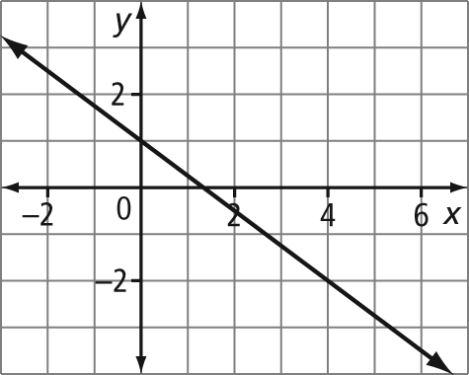a) 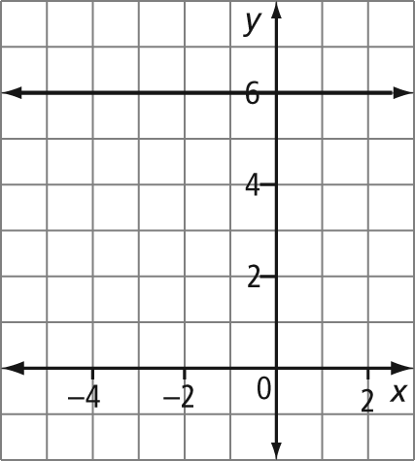 b)

_______________________________ _______________________________

1. Match each of the equations below with its graph. Justify each choice

 



Equation:

Justification



Equation:

Justification



Equation:

Justification

1. Identify the slope of a line parallel to each given line.

a) y = x + 9

b) 4x + 6y = 20

1. Identify the slope of a line perpendicular to each given line.

a) y = 2x – 4

b) 3x + 5y = 35

1. a) Graph each line below. Make sure you label each line.



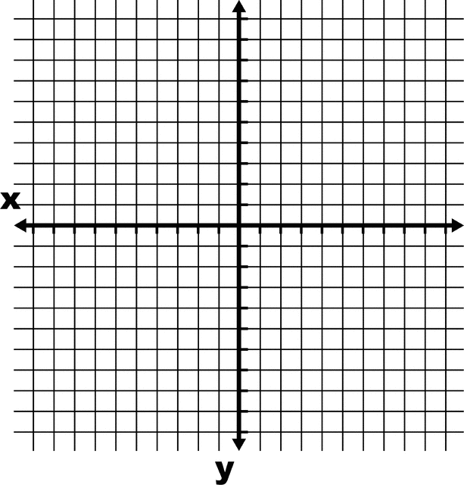

1. Determine the equation of the line that is parallel to the line with the equation $y=3x+5$, and passes through A(6,2). Explain how you know your equation is correct.
2. Determine an equation of the line that is perpendicular to the line with equation $y-3=\frac{1}{3}(x+2)$ and passes through B(-1 , 2). Write the new equation in general form.
3. Write the equation of each line in the form that you think best describes the line



**Extended Response**

12. A hot-air balloon is rising at a constant rate of 0.75 m/s. The equation that represents the height of the balloon, h, in metres, as a function of time, t, in seconds, is  
h = 0.75t + 3.

a) What does the h-intercept of the graph of the relation represent?

b) How high will the balloon be after 20 s?

c) How long will it take the balloon to reach a height of 15 m?