1.
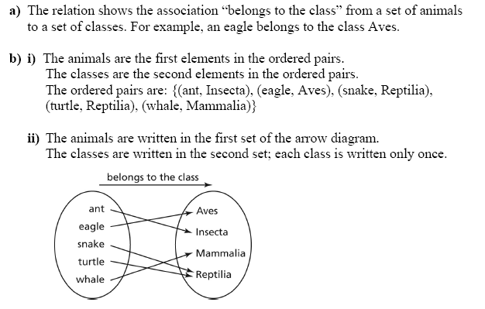
2.
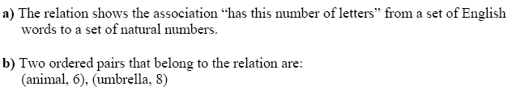
3.
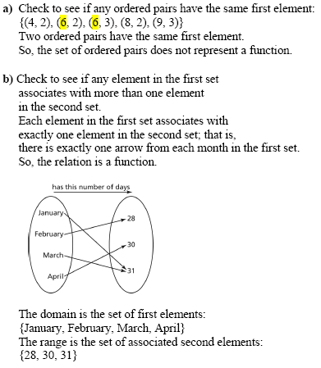

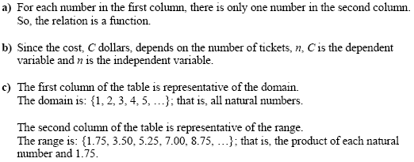
4)
5)
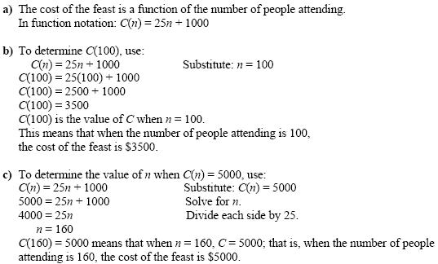

6. a) 24 – 4 +1 =21 b) 54 – (-6) +1=61 c)

7) -2

8.
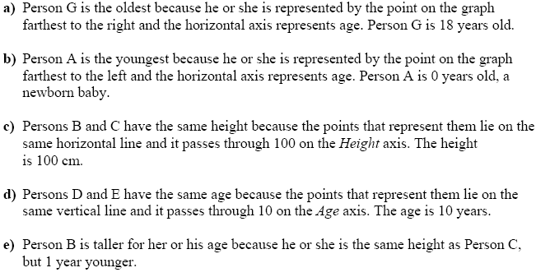
9. Lance rides his bicycle in his neighbourhood for exercise. The graph below shows his ride from his home to the shore of the Fraser River and back.
- Approximately how long did Lance ride around his neighbourhood? 110 minutes
- How many kilometers away from Lance’s home is the Fraser River? 8 km
- On the way to the river, Lance stopped to talk to a friend. How far away from home was he at that moment? 5 km
- How much time did he spend along the shore of the Fraser River? 10 mins

10. a) Yes, any vertical line drawn on the graph passes through 0 or 1 point. b) No, because the vertical line test does not pass at 175 cm.

11. a)Domain
$\left\{x | x≤5,x∈R\right\} or [-∞,5]$
Range:
$\left\{y | y≤2,y∈R\right\} or [-∞,2]$

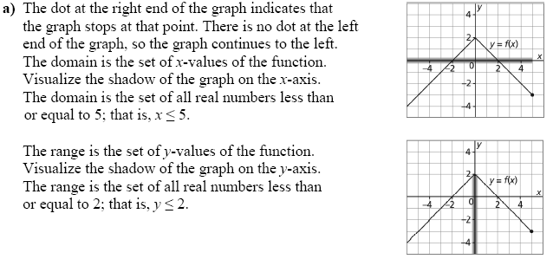
b) Domain
$\left\{x | -3≤x≤5,x∈R\right\} or [-3,5]$
Range:
$\left\{y | 3≤y≤7,y∈R\right\} or [3,7]$

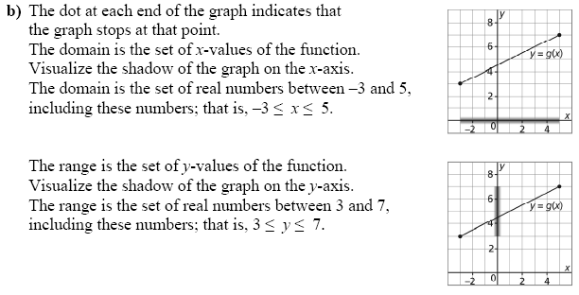

12.
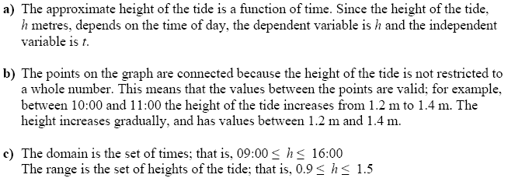

13) $h\left(36.87\right)=2.8×36.87+70.6$
$h\left(36.87\right)≈174cm (rounded to the nearest cm)$
14. Here is a graph of the function g(x) = 4x – 3.
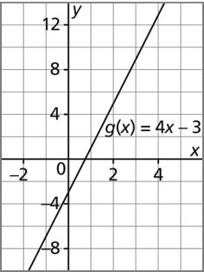
a) Determine the range value when the domain value is 3.
9

b) Determine the domain value when the range value is –7. -1

14. Express “y” as a function of ‘”x”. Include the domain and range of the two variables.
x

y

15.
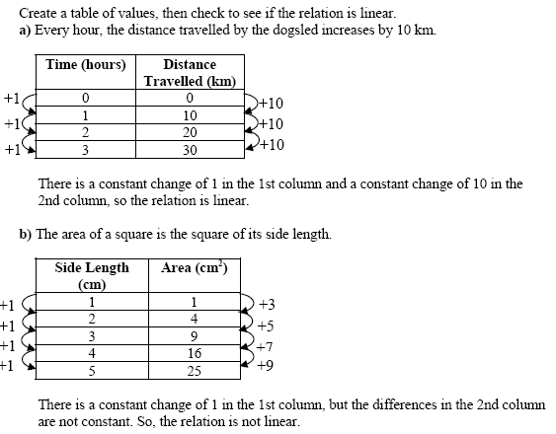

16.
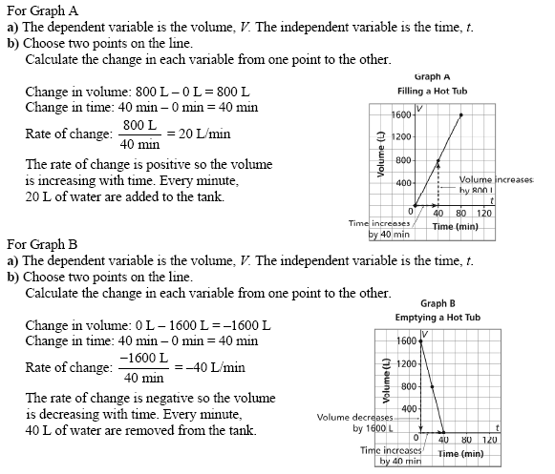

- To use a mini race car at the fun park, the cost is $12 for a tank of gas plus a rental fee for every hour of driving. It cost $22 to race the car for one hour. Assume that you are billed per minute of driving and you are only allowed to rent the car for a maximum of 4 hours.

- Graph this relationship. Be sure to label
both axis and pick and appropriate scale.
60
50
- What is the hourly rental rate?
$10/hour
40
- How much does it cost to rent the
car for 2 hours and 15 minutes?
30
Cost in ($)
15 minutes = 0.25 hours
20
2.25 x 10 + 12 = $34.50
10
- What is the domain of the graph?
Domain is the amount of time that you
4
can rent the car for.
3
1
2
$0≤t≤4$

- What is the range of this graph?
Time in hours

Range is the cost of driving the car
$12≤C≤52$

