Pricing Strategy Questions
- What are the five different types of pricing strategies? Briefly describe each type.

- What pricing strategy do you think would work best for technological innovations like the smart phone?

- According to the graph below (in the second article), which company has the highest market share in Q2 of 2017? Which company has the lowest market share in Q2 of 2017?
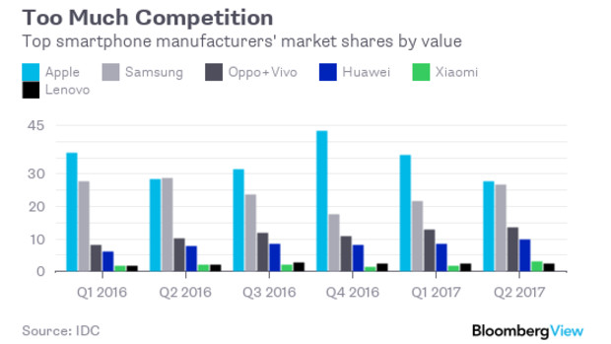

- According to the graph, briefly describe what has happened to the market shares of the different companies. What changes have taken place?

- According to the author in this article, what made Samsung successful?

