Car Financing Assignment
Step 1: Say “yes” to the car
Go to one of the sites listed below and choose a car to buy. When you are buying a car, make sure you consider the following criteria:

- Size of your car – how many people do you need to fit in your car?
- Fuel economy – how many kilometres can you travel per litre?
- Electric/Hybrid?
- Standard/Manual vs. Automatic?
- Four-wheel drive?
- Back up camera?
- Air conditioning?
- How much cargo space do you need (how big is the trunk)?
- What kind of warranty?
- New or Used?

Buying a new car |  | Buying a used car
Pros | Cons | Pros | Cons

Once you’ve thought about what kind of car is important to you, please go to the site below and browse through the different cars.

- https://www.destinationauto.ca/
Based on your given family situation, please choose a car that makes sense for you.

Car Maker: ______________________
Car name: ______________________
Year: _____________
Price: ______________
New or Used: ___________
Car Review (out of 5 according to Edmunds
__________

Reasoning for your choice:
___________________________________________________________________________________
___________________________________________________________________________________
___________________________________________________________________________________
Step 2: Decide how you will pay for your car!
Option 1: Cash purchase – you have been patient and disciplined and saved enough cash to pay for the vehicle without borrowing any money.
Option 2: Financing - you make a down payment in cash and borrow the rest.
Option 3: Leasing - basically like renting the car
Let’s look at how financing would work for your car (Option 2)
- Google “Auto Loan Payment Calculator” and click on Scotiabank’s site.

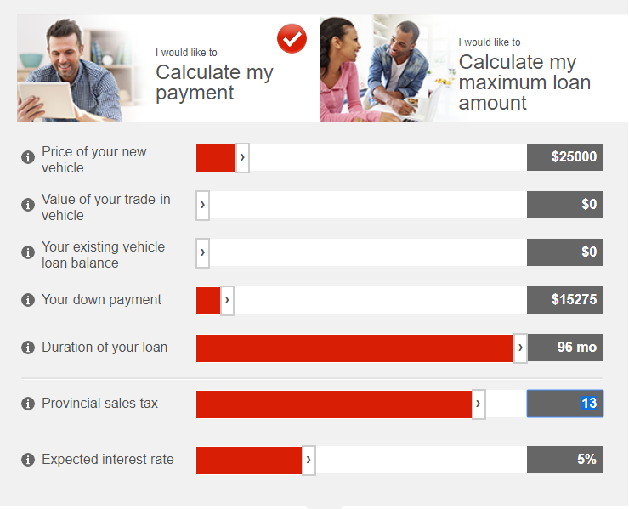
- Scroll down to adjust the different options (price of your car, down payment, duration of loan, and expected interest rate). Ask a teacher about what a down payment, monthly payment and total interest paid means as you’re doing this task.
Put price of the car you have chosen
Try at 12 months, 24 months and 48 months
Change to 5%
Keep at $10,000

After you have adjusted all of your options, scroll down and check out the numbers!
What is your monthly payment with three different durations?
- 24 months _____________________
- 36 months _____________________
- 60 months ____________________
What is the total interest to be paid over the duration of the loan?
- 24 months _____________________
- 36 months _____________________
- 60 months _____________________
Step 4: Financing Analysis
- What happens to your monthly payment when you take a longer time to pay off your loan (e.g. paying off in 60 months instead of 24 months)
____________________________________________________________________________
- What happens to the total interest you pay when you make the duration of your loan longer?
_____________________________________________________________________________
- What happens to your monthly payment and the total interest you pay when you increase your down payment?
___________________________________________________________________________
- Why is it a good idea to save up for a down payment on a car?
______________________________________________________________________________________________________________________________________________________________________
- What is a potential disadvantage or challenge of saving up for a down payment on a car?
______________________________________________________________________________________________________________________________________________________________________
- According to CBC’s Marketplace episode, what are some of the issues with how car dealerships explain the financing of a car (Name a minimum of five things throughout the video)

- _________________________________________________________________________
- _________________________________________________________________________
- _________________________________________________________________________
- _________________________________________________________________________
- _________________________________________________________________________

Step 5: Other costs of having a vehicle
You now have a car; brainstorm a list of costs that will be added to your budget now that you own a car.
______________________________________________________________________________________________________________________________________________________________________
______________________________________________________________________________________________________________________________________________________________________
Car Insurance: Using the site on my website for ICBC, we will go through the different aspects that will affect the price of your monthly insurance.
What factors affect the price of your car insurance?
- How you _______ your vehicle
- _________ you live or ______ your vehicle
- __________________ and ___________ history
- _______________ of _______________________
- Your __________________
- The ________________ you drive.

Other maintenance

