DEFINITIONS
- Gross earnings: money earned before any deductions
- Pay periods: how often you are paid
Monthly = once a month
Semi-monthly = twice a month
Weekly = once a week (52 times a year)
Biweekly = every two weeks (26 times a year)
- Salary: an employee receives an equal amount of money per pay period
- Commission: an employee’s earnings are based on a percentage of sales
- Graduated commission: an employee’s earnings are based on a percentage of sales, but the percentage increases as sales increase
- Salary plus commission: an employee gets a base salary and commission is added to that base salary
- Piecework: an employee’s earnings are based on production

EX1 Write each percent in decimal form
- 12% b) 7% c) 150% d) 6.2%
0.12 0.07 1.5 0.062

EX2 Calculate 12% of $32576
0.12 x 32576 = $3909.12

EX3 A pair of skis is $740. Avery found a sale and saved $36. What percent discount is $36?
$$\frac{36}{740}×100=4.9\%$$

EX4 Sharon works full time at a gas station. She is paid $13.95 per hour plus time-and-a-half for overtime, which is any time over 40 hours in a week. Calculate her gross earnings for a week in which she worked 46 hours.
$683.55

EX5 Anna works at a furniture store where she earns a graduated commission. She earns 9% commission on the first $10000 worth of sales she has, and 12% commission on anything exceeding $10000. In May, Anna’s sales were $21675. Calculate her gross earnings for the month.

$2301

EX6 Travis has job offers from two clothing stores. Store A will pay $11.45/hour. Store B will pay a base salary of $1100 per month plus 4% commission on sales. Both stores want Travis to work 160 hours per month. Above what sales will Travis make more money in Store B?

If he makes more than $18,300 in sales, he will make more money in Store B

Individual Practice:
- Sarah earns $526 per week. If she works 50 weeks a year, what is her annual gross income?

$26300
- John is a welder. He earns $34.25 per hour. How much would he earn in an average 40-hour work week?

$1370

- If John works 48 weeks of the year, and averages 38 hours per week, what would be his annual gross pay?
$62,472

- Paul earns a base salary of $900 a month plus a commission of 7% on total sales. Last month, he had a total of $26324 in sales. Estimate his gross earnings.

$2742.68

- Calculate the gross earnings per month for each person:
- Joe works in a restaurant 27 hours a week. He is paid $13.00/hour and receives $134 in tips.

$485
- Max worked 46 hours last week. He was paid $14.50/hour and double time for overtime. His normal work week is 40 hours. (overtime is anything over 40 hours)

$754
- Jack, a salesperson at an appliance store, earns 12% commission. Last week, his sales totaled $5675.
$681

- Megan plants trees. She is paid $0.35 for every tree she plants. One week she planted 4350 trees.
$1522.50

- Iliana works as a server. She earns $10.45 per hour and keeps 70% of the tips she receives. The other 30% is shared among the hostess and cooks. Iliana worked 34 hours last week and received $254 in tips, before sharing. What is her gross pay?

$533.10

Calculating Net Pay:
If you don’t have a job already you will soon see that there are certain deductions that will be taken off your pay cheque. These deductions include…
- Federal and provincial income tax
- Canada Pension Plan (CPP)
- Employment Insurance (EI)
Other deductions may include:
- Union dues
- Registered Pension Plan (RPP) Contributions
- Health and/or Dental insurance
After all deductions are taken off your gross pay, you are left with net pay
Below are the federal tax rates:
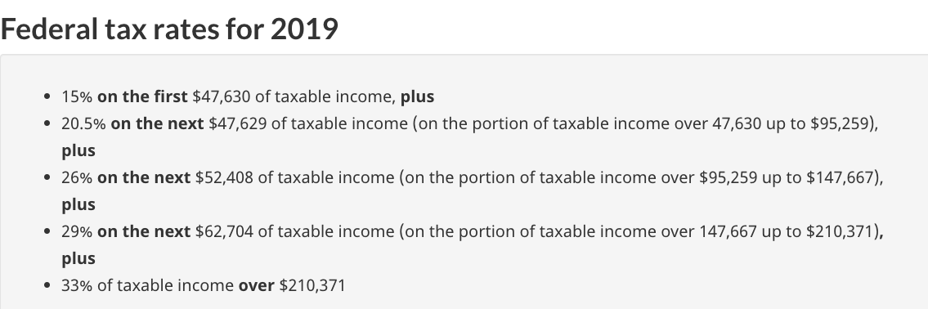
These are the provincial (BC) tax rates:
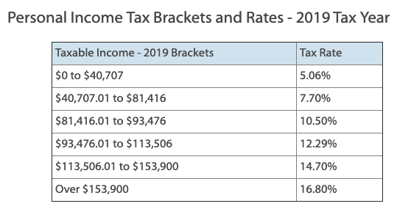
Question 1:
Darren’s annual gross salary as a boat engine mechanic is $30,987.
He finds the following deduction rates for his situation online:
- Federal income tax is 15% of gross income
- Provincial income tax is 5.06% of gross income
- CPP is 5.1% of gross income, to a maximum of $2748.90
- EI is 1.62% of gross income, to a maximum of $860.22.
a) What is Darren’s annual net income?
Federal tax = $4648.05

b) If Darren is paid bi-weekly, what are his net earnings for one pay?

Question 2: Andrea earns a monthly salary of $3425. Each month, in addition to the mandatory deductions, she pays $45 in union dues and $225 into RPP. Find her monthly net earnings.

Question 3:
Oliver earns $15/hour at Sportsworld. If he works more than 40h in 1 week, he receives time-and-a-half for the overtime hours. This week, Oliver worked 50h.
- What was Oliver’s gross pay this week?
- What was his net pay this week?

Question 4:
An industrial carpenter provides finish work for new stores. The details of her job are:
- Regular hourly wage: $24.30
- Overtime pay (time-and-a-half) for more than 40h per week.
- Health insurance deduction: $28 per month
- Union dues $5.50 per month
- Bi-weekly pay
- Week 1: 42 h, Week 2: 40h, Week 3: 40h, Week 4: 44h.
What is the carpenter’s net pay this month?

Challenge:
- The average nurse in Canada earns $74,926 per year. Calculate their net income after the mandatory deductions.
- What other additional deductions might a nurse have?

